Add : 71 Bukit Tinggi Road, singapore 289759
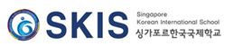 | Press Release | 

The date and time of the Press | Unlimited (immediate) | The date and time of the Distribution | 12th April(Wed), 2023.14:00

Inquiry | Vice principal | Lee Jaehum | ☎  +65-6741-0778  070-4064-3995  070-4065-3995 | General Manager | Hong Yongwhan | ☎  +65-6741-0778  070-4063-3995
Inquiry | Head of Middle & High | Lee  Jinwoo | ☎  +65-6741-0778  070-4064-3995  070-4065-3995 | Head of Management | Tina Lee | ☎  +65-6741-0778  070-4063-3995
Inquiry | Head of Elementary | Nro Yurim | ☎  +65-6741-0778  070-4064-3995  070-4065-3995 | Head of Kindergarten | Han Soomin | ☎  +65-6741-0778  070-4063-3995

Singapore Korean International School,
Celebrate the 30thanniversary of its founding
The history of the school is the history of overseas
Koreans, with part 1 and 2 of outstanding events

Singapore Korean International School(SKIS, Principal Yang Mee suk) holds a commemorative event to celebrate the 30th anniversary of its founding in the school hall at 2 pm on 20 April(Thurs), 2023.
The event will be divided into a first-part ceremony, a student celebration performance, and a second-part forum, and a total of 300 people, including Choi Hoon, ambassador to Singapore, and Chung Gun-jin, chairman of SKIS, students, teachers, staff, and parents of SKIS, local personnel will attend.
The first part of the event will open with Samulnori, Korean traditional percussion quartet, performed by elementary school students. Then, it is followed by national rituals, school history reports, commemorative videos, commemorative speeches and congratulatory speeches, commendations for distinguished faculty members, and finally student performances.
In commemoration of the 30th anniversary, Lee Jong-mal(Tina Lee, 20 years of service) and Morthi(Singaporean, 12 years of service) were selected as distinguished faculty members and awarded the plaque.
In addition to kindergarten students' singing the Korean national anthem and performing Taekwondo, which showed their identity as Koreans, the G4 students will sing the Singapore national anthem. The 30th anniversary video produced by middle and high school students will be expected to evoke great emotion and response.
Ambassador Choi Hoon will congratulate on the 30th anniversary of the opening of SKIS, saying, "I hope that SKIS, which has played a central role among overseas Koreans as well as in the education of their children for the past 30 years, will continue to be the cradle of fostering future talents.”
The second part of the event will be held as a forum attended by a total of six overseas education experts and school members under the theme of "Discussion for a New Leap of Singapore Korean International School.”
Professor Kwon Oh-Hyun of Seoul National University, who heads the Overseas Education Support Center, will lead the forum. SONG JU-HA, a professor at Nanyang Technology University in Singapore, and CHI SEO WON, a professor at the National University of Singapore, will participate as local overseas education experts and present the current status and tasks of SKIS one by one.
After the expert presentation, there will be a comprehensive discussion involving school representative JEONG GUAN JIN(the chairman of SKIS), parent representative OH YANG TAEK(the chairman of the school's steering committee), and teacher representative Kang Eun Ha, which is expected to present mid-to long-term development measures for a new leap forward in SKIS.
The chairman of SKIS, JEONG GUAN JIN expressed expectations for the forum, will say, "This forum is also a place to celebrate the achievements of SKIS over the past 30 years, and it is designed to explore new visions that will open up the next 30 years.”
On the other hand, SKIS was founded in 1973 and officially opened as a Singapore International Korean School in 1993. With its steady growth, as of April 2023, a total of 350 students attended the regular curriculum of kindergarten, elementary, middle and high schools, and 400 students attended Saturday Korean Schools. As a result, the status of the school has been raised to become the only international school officially accredited by both Korea and Singapore.

Attached | Celebrate the 30th anniversary invitation letter and poster

< Invitation Letter >
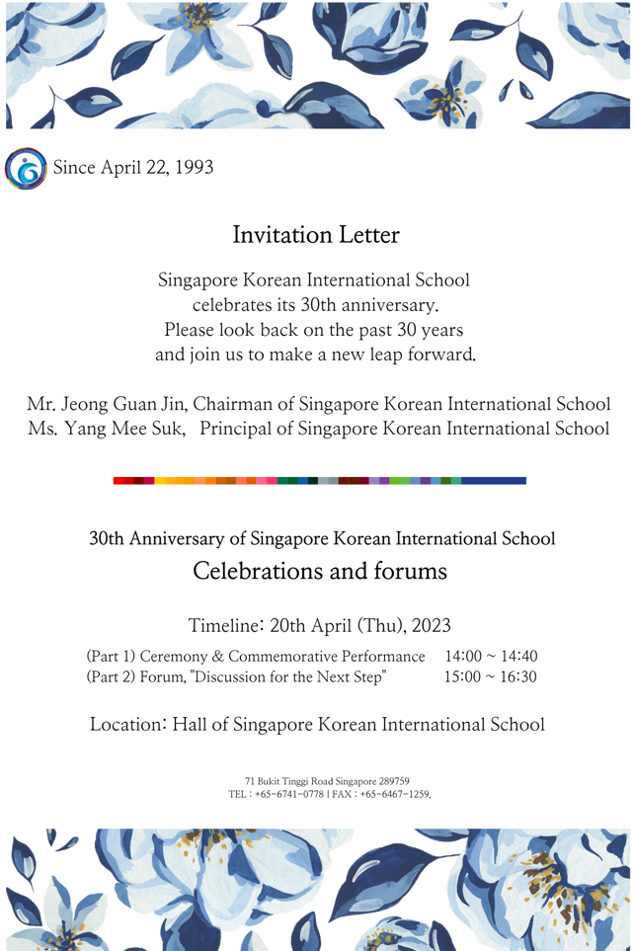

< Poster >
