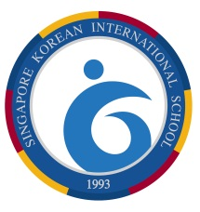 | - SINGAPORE KOREAN INTERNATIONAL SCHOOL
ELEMENTARY ENGLISH DEPARTMENT
Building Bridges through English Language
Nurturing Global Citizens
15 May 2026
Dear Parents,

Please be informed that the annual English Creative Writing Contest will take place in Week 15, from 15-19 June 2026. Writing preparations have begun in the respective Literacy classes and the final submissions will be made during Week 15.

The English Creative Writing Contest is designed to nurture creativity, self-expression, and confidence in the students through storytelling in various forms, such as short stories or poems. It aims to provide the students with an opportunity to hone their English language and literacy skills while exploring their imagination. Through the process of preparing for the contest, students are encouraged to think critically, organize their ideas clearly, and develop a love for reading and writing.

The selected theme for this year’s contest is “Celebration”. Students will be encouraged to delve into the theme through different perspectives, from personal celebrations such as birthdays and personal milestones, celebrating cultural festivities to a broader outlook such as celebrating famous scientists or showing appreciation for nature. Given the broad scope of the theme, students will also have the opportunity to explore various writing forms such as personal recounts, discursive essays and poetry as creative means of expressing self-identity and imagination.

Thank you always for your kind support and cooperation. The teachers look forward to reading the submissions and are eager for the students to bring their creativity and ideas to life.
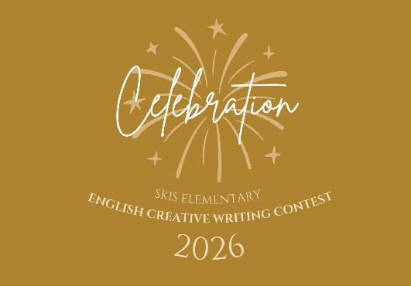

SINGAPORE KOREAN INTERNATIONAL SCHOOL PRINCIPAL

